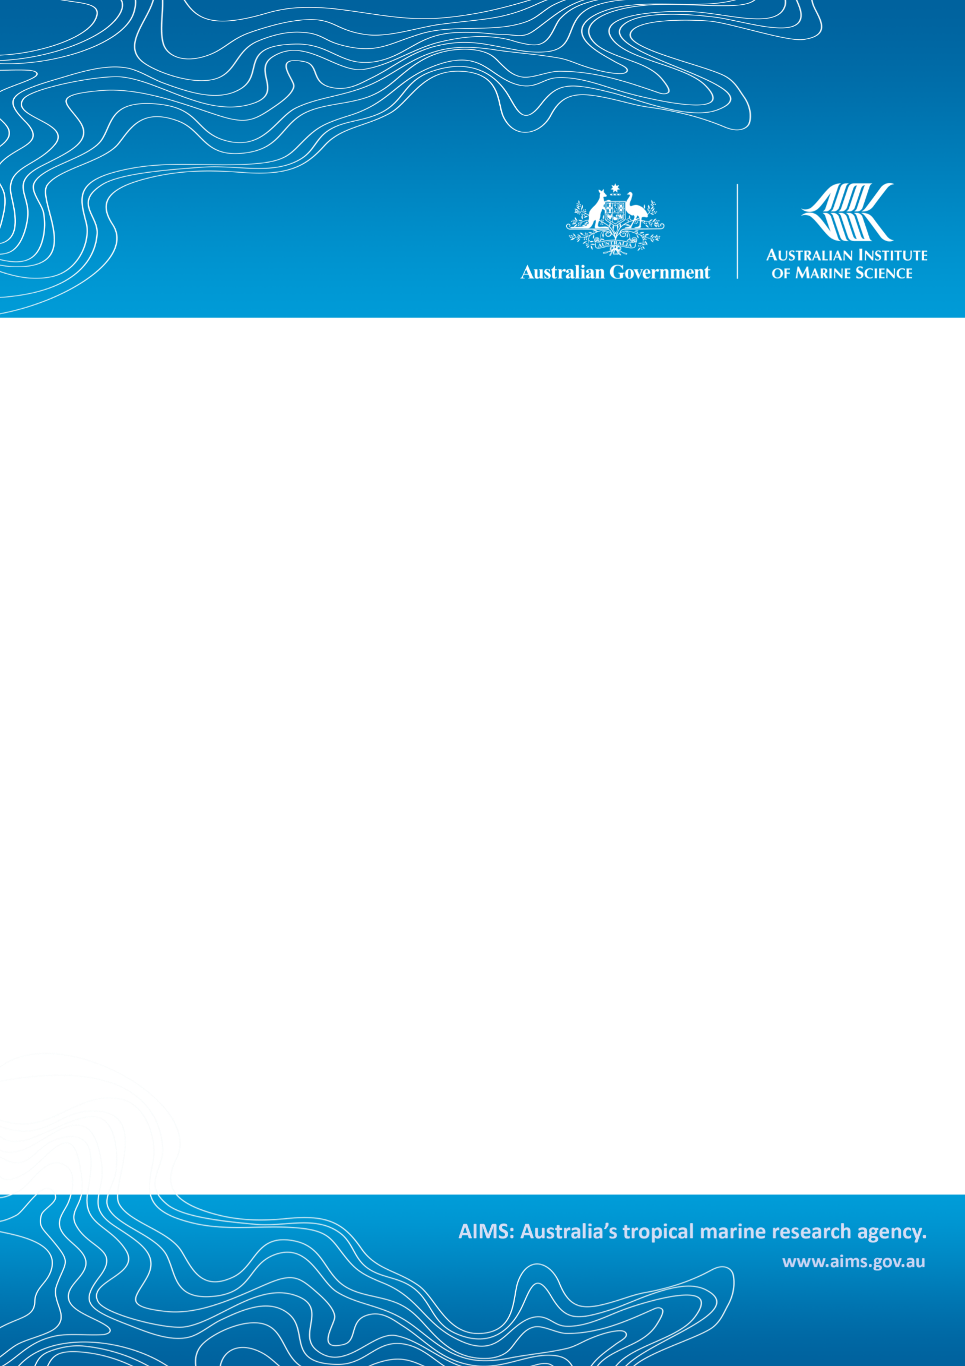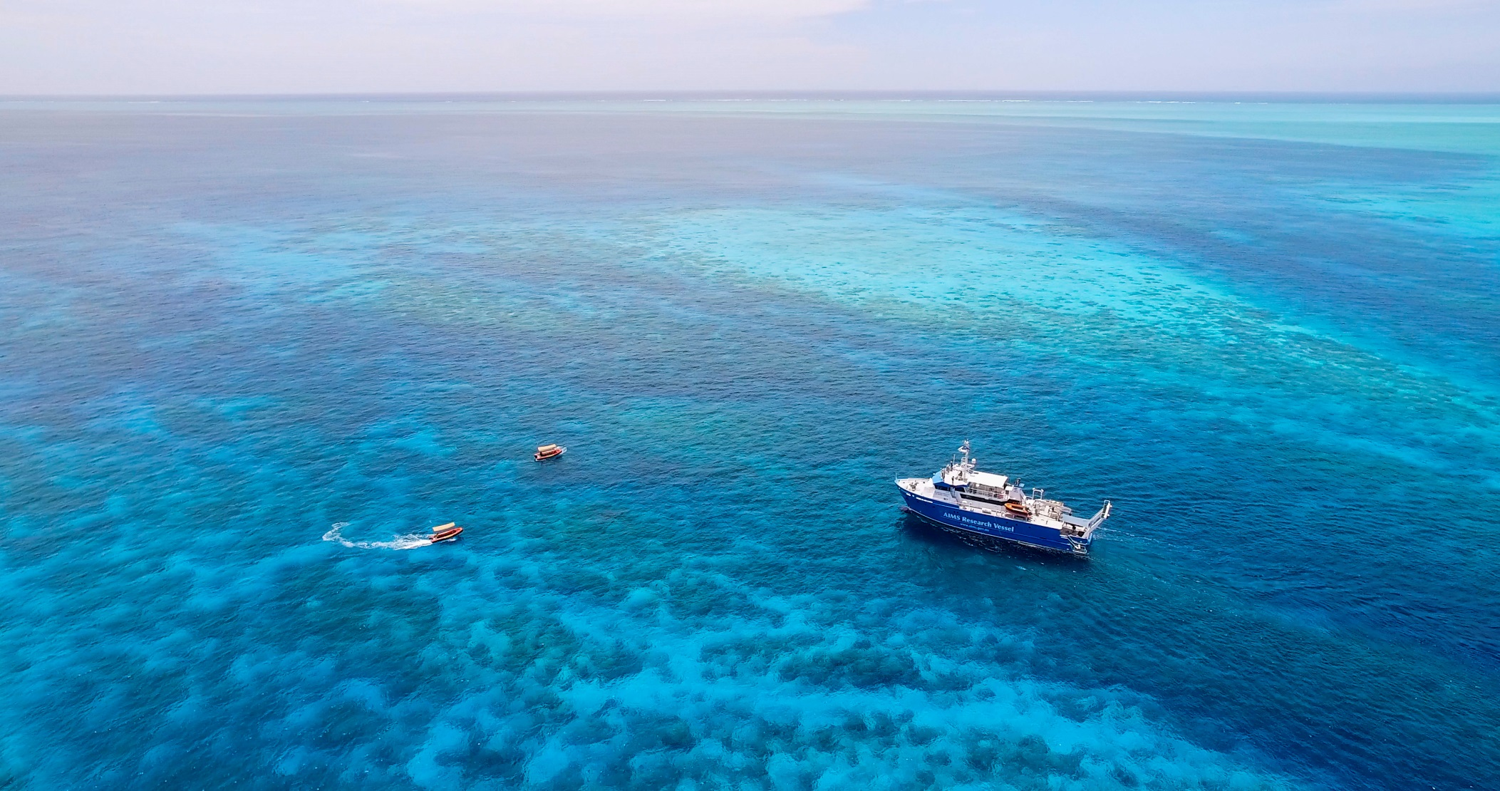

An exploration of the associations between pressures and stressors in Darwin Harbour water quality parameters

<subtitle> =

Murray Logan

A document prepared for Northern Territory Government, Department of Environment, Parks and Water Security

**Australian Institute of Marine Science**

|  |  |  |
| --- | --- | --- |
| PMB No 3  Townsville MC Qld 4810 | PO Box 41775  Casuarina NT 0811 | Indian Ocean Marine Research Centre  University of Western Australia, M096  Crawley WA 6009 |

This report should be cited as:

*Logan, M (2023). An exploration of the associations between pressures and stressors in Darwin Harbour water quality parameters. Report prepared for Northern Territory Government, Department of Environment, Parks and Water Security. Australian Institute of Marine Science, Location. (2 pp)*

© Copyright: Australian Institute of Marine Science (AIMS) *2023*

All rights are reserved and no part of this document may be reproduced, stored or copied in any form or by any means whatsoever except with the prior written permission of AIMS

**DISCLAIMER**

While reasonable efforts have been made to ensure that the contents of this document are factually correct, AIMS does not make any representation or give any warranty regarding the accuracy, completeness, currency or suitability for any particular purpose of the information or statements contained in this document. To the extent permitted by law AIMS shall not be liable for any loss, damage, cost or expense that may be occasioned directly or indirectly through the use of or reliance on the contents of this document.

|  |  |  |  |  |
| --- | --- | --- | --- | --- |
| Project Leader shall ensure that documents have been fully checked and approved prior to submittal to client | | | | |
| **Revision History**: | | *Name* | *Date* | *Comments* |
| 1 | Prepared by: | *Insert Lead Author’s name* | *Insert date* |  |
| Reviewed by: | *Insert Reviewer name* | *Insert date* |  |
| Approved by: | *Insert Program Director’s name* | *Insert date* |  |
| 2 | Prepared by: | *Insert Lead Author’s name* | *Insert date* |  |
| Reviewed by: | *Insert Reviewer name* | *Insert date* |  |
| Approved by: | *Insert Program Director’s name* | *Insert date* |  |

*Cover photo:*

*Current picture ‘RV Solander in Western Australia. Image: N. Thake*